CIWA implementation in the Emergency Department
- Complete patient history, ask patient: “Do you drink alcohol daily?”
  - If patient answers “yes”
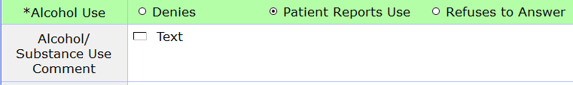
  - In the text box include how much and how often they consume alcohol.
  - Once you save the patient history information you should receive a pop up box that is similar to when you answer yes to the SI questions that will say “ CIWA assessment needed”
- Next, add your CIWA assessment under interventions
  - This will auto populate to perform under the BH and Substance abuse chief complaints.
  - Once this assessment is completed and the patient scores anything above ZERO you will receive a pop up that will then say “Notify provider now, consider adding order set, perform reassement Q2H”
  - If the patient scores greater than a ZERO, the assessment must be performed Q2H until the patient is a ZERO or is discharged/admitted. There will be a reminder on the tracker much like the NIH and PAIN reassessments.
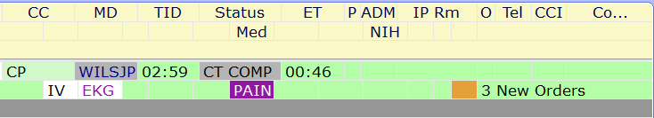
CIWA
- Lastly, add the order set
  - Click order 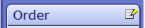
  - Click yes 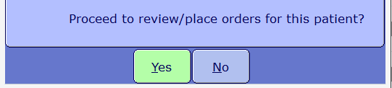
  - Click okay 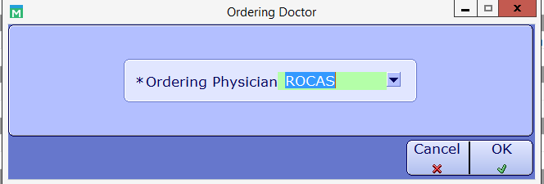
  - Type Verbal and click Okay 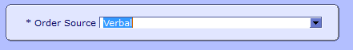
  - Under Order sets:
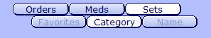
  - Drop down Emergency and select EDz: Protocol Sympt Alcohol Withdrawal
  - Select and Save the order set as is.
  - Give medication according CIWA assessment and protocol

